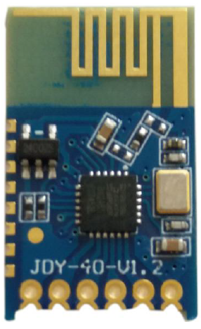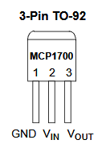
P0.0 P0.1
GND
5Vo
5Vi
MCP1700
Vin 2

3 Vout

GND
1

EFM8 Board
1µF
1µF
JDY40 connections to the EFM8 Board.
3.3V
~4.8V
P2.0

